MAG LEVEL 3 FLOOR (1)
Statics | 1. ® © Scale | 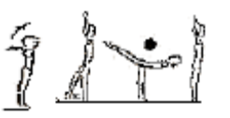
  - From stand, step forward, raise one leg backward to front scale (hold 2 secs). Lower leg from scale to stand with feet together and arms raised.
 | 2. ® © Straddle Balance, Front Support | 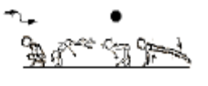
  - From squat, place hands on the floor and jump hips upward, straddling legs at least 90º to straddle stand, trunk horizontal. Hold 2 seconds. Place hands on the floor and jump legs backward to front support.
 | 3. ®* Side Splitz, Front Support | 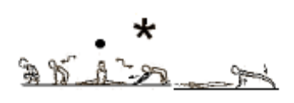
  - From squat, place hands on the floor and jump hips upward, straddling legs, lower to side splits, arms outward (2 secs). Place hands forward on the floor and lower chest to floor, bring legs together, place hands by chest and push up to front support position
Fwd Roll | 1. ®© Front Support, Fwd Roll, Jump 1/1 turn | 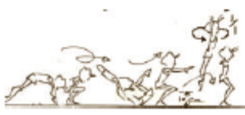
  - Jump to squat, tucked forward roll and vertical stretch jump with 1/1 turn to stand.
Handstand (for walkover, handspring and flic flac) | 1. Handstand with nose against wall – looking at hands – covering ears, hips open, bottom squeezed. Push “tall” up the wall – 40 secs
 | 2. F2-1.6 Handstand with feet touching a bar – hold for 20-30 sec | 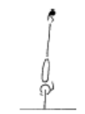 | - arms straight  - chest rounded, extended through the shoulders  - hips open  - gluteal muscles squeezed  - head neutral  - maintain good body tension and alignment
 | 3. F2-1.7 Handstand walking | 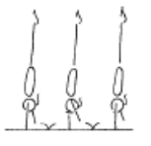 | - arms straight  - chest rounded, extended through the shoulders  - hips open  - gluteal muscles squeezed  - head neutral  - maintain good body tension and alignment
 | 4. F2-1.8 Handstand ½ turn – recommend 2 hand placements per turn | 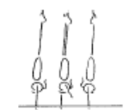 | - arms straight  - chest rounded, extended through the shoulders  - hips open  - gluteal muscles squeezed  - head neutral  - maintain good body tension and alignment
 | 5. Handstand holding on to object hanging from rings
 | 6. Handstand against horse
 | 7. Handstand on parrallettes
 | 8. F2-1.2 From squat perform a small jump to tuck, straddle or pike handstand
Handstand Fwd Roll | 1. Handstand fwd roll to L-sit, reach fwd to pike stretch, candlestick, roll to stand
 | 2. ®© Handstand Fwd Roll | 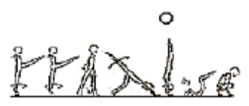
  - Take 2 steps forward (i.e. left then right, raised leg at least hip height each time), step forward onto left leg and kick through momentary handstand to roll forward to squat.
 | 3. F3-2.4 Fwd roll to tuck handstand, fwd roll to straddle handstand, fwd roll to pike handstand fwd roll series | 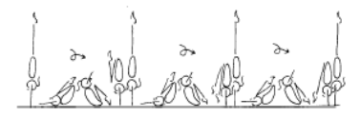

MAG LEVEL 3 FLOOR (2)
Cartwheel / Roundoff | 1. Lying on back on floor – start in star position and turn hips/shoulders ¼ turn each way to learn ¼ turn
 | 2. Against a wall – cartwheel to stop in handstand – coach assists gymnast to ¼ turn and step down
Cartwheel / Roundoff  Con’t | 3 © From feet together, jump to hurdle, cartwheel, cartwheel step in (snap up) | 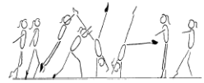 | - start with square hips and shoulders in the direction of travel  - lunge into the cartwheel maintaining square posture  - kick to a vertical side handstand with a small straddle  - first hand is placed same as a side cartwheel and becomes the support and rotational hand  - second hand is turned a 1/4 turn and placed pointing towards the first hand and becomes the repulsion hand  - head neutral  - body rotates 1/4 turn so that shoulders and hips are now square and facing the direction of travel  - head is neutral and eyes can see where the foot is about to land  - keep arms straight and chest in  - once the body is vertical over the second hand the chest lifts and the feet come down causing a ‘see-saw’ illusion  - the shoulders must not go past the vertical line  - finish in a stand with arms forward low horizontal  - chest in, hips open
 | 4. ® ©Cartwheel with a ¼ turn outwards | 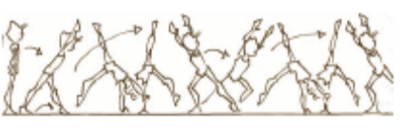
  - Raise left leg forward (at least hip height), step to 2 x cartwheel, turn 90º outward to face forward.
 | 5. F4-2.5 Perform a roundoff from a rebound surface to a lower landing surface – to feet | 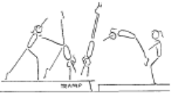 | - ensure the body remains within the vertical plain, no pike or arch action  - maintain good body tension and alignment  - repulsion from hands occurs during the vertical phase when the body is travelling upwards with the heel drive  - land in a dish shape with arms forward low horizontal
 | 6. Corbett snapdowns from a beatboard or box – rebound on landing | 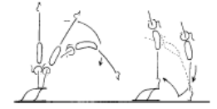 | - maintain body tension and alignment  - head neutral  - hands slightly turned in  - shoulders remain over the initial support position  - bounce from the floor
 | 7. F4-2.7 Perform a roundoff over a shape | 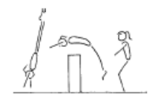 | - ensure the body remains within the vertical plain, no pike or arch action  - maintain good body tension and alignment  - repulsion from hands occurs during the vertical phase when the body is travelling upwards with the heel drive  - land in a dish shape with arms forward low horizontal
 | 8. F4-2.8 Run roundoff from a board to land in a rebound against an incline mat | 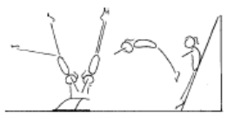 | - ensure the body remains within the vertical plain, no pike or arch action  - maintain good body tension and alignment  - repulsion from hands occurs during the vertical phase when the body is travelling upwards with the heel drive  - land in a dish shape with arms forward low horizontal
 | 9. Roundoff | 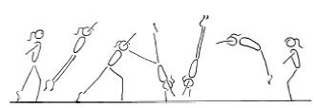 | - start with square hips and shoulders in the direction of travel  - lunge into the round off maintaining square posture  - kick to a vertical position  - first hand is placed same as a side cartwheel and becomes the support and rotational hand  - second hand is turned a 1/4 turn and placed pointing towards the first hand and becomes the repulsion hand  - gymnast must be in line with the first hand  - head neutral  - body rotates 1/4 turn so that shoulders and hips are now square and facing the direction of travel  - head is neutral and eyes can see where the feet are about to land  - keep arms straight and chest in  - once the body is vertical over the second hand the chest lifts and the feet come down causing a ‘see-saw’ illusion  - the shoulders must not go past the vertical line  - finish in a rebound with arms forward low horizontal  - chest in, hips open

MAG LEVEL 3 FLOOR (3)
Backward Roll (for back salto) | 1. © Bwd roll to straddle or pike stand, ¼ turn, slide to fwd splits, join legs to sit, lift to side support, kneel, chest to knees, lift chest, kick leg, step up to stand |  | - Legs together  - Smooth rolling action  - Legs and arms straight
 | 2. Bwd roll to candlestick
 | 3. Bwd roll to front support
 | 4. Bwd roll to front support with feet raised on box – gradually raise height of boxes | 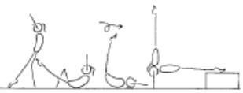 | - maintain body tension and alignment  - head neutral
 | 5. F2-4.5 Back extension roll down an incline to handstand with straight arms (then on the floor) | 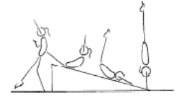 | - maintain body tension and alignment  - head neutral
FWO, BWO & Tic Toc | 1. F4-1.2 “rock and roll” in a bridge position | 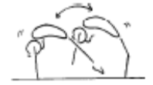 | - feet and hands come off the ground at the peak of each sway  - maintain good body tension and alignment  - keep arms straight throughout the skill  - keep legs as straight as possible  - emphasise the use of hip and shoulder flexibility
 | 2. F4-1.3 Perform a split handstand against the wall | 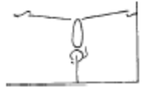 | - maintain good body tension and alignment  - gymnast actively tries to push legs down  - maintain a vertical handstand from hands to hips
 | 3. F2-5.5 From kneel, perform a bridge onto a high raised surface and return to stand
 | 4. Limber from stand – down to bridge and up again
FWO, BWO & Tic Toc  Con’t | 5. F2-5.7 Bridge from standing kickover to stand (back limber) | 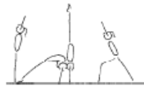 | - keep hips in line with feet  - stretch up first then open shoulders to initiate the bridge  - keep gluteal muscles tight  - maintain good body tension and alignment  - legs straight in the kick over (legs can be together - advanced, or in split)
 | 6. F2-5.8 Kick to handstand into a bridge, stand (front limber) | 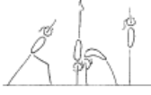 | - keep hips in line with hands during the handstand  - support phase  - stretch up first then open shoulders to initiate the bridge  - keep gluteal muscles tight  - maintain good body tension and alignment  - head neutral  - use the muscles in the legs and hips to stand
 | 7. F4-1.1 From stand, start with 1 leg raised perform a bridge onto a raised surface and return to stand | 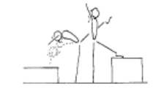 | - arms by ears with eyes looking at hands  - use shoulder and hip flexibility  - straight arms throughout the skill
 | 8. F4-1.4 Perform the walkover with some assistance from a coach | 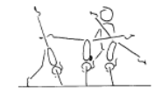 | - arms by ears with eyes looking at hands  - use shoulder and hip flexibility  - straight arms throughout the skill  - pass through a vertical handstand position with legs in stride
 | 9. Fwd or Bwd Walkover | 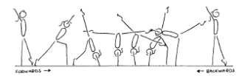 | - arms beside ears during all phases of the skill, with eyes looking at hands  - front walkover and tic-toc must pass through a vertical handstand prior to opening the shoulder angle to  - allow the bridge to occur (back walkover must start in a vertical stand before going back into the bridge phase)  - 180’ split of legs during the skill  - keep back and/or front legs still during scale phase  - arms straight, thumbs parallel and together  - the bridge action uses the hip and shoulder flexibility  - maintain good body tension and alignment  - square hips and shoulders throughout the skill

MAG LEVEL 3 FLOOR (4)
Hurdle | 1. F4-2.4 Continuous hurdles across the floor – ensure the correct position | 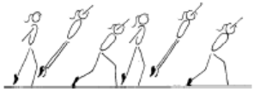 | - maintain good body tension and alignment  - chest in, hips under  - arms by ears  - generated power and forces  - head neutral
Handspring | 1. F4-4.1 Lunge from 1 step, into a fast handstand to a supersoft mat against the wall | 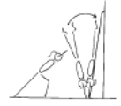 | - maintain good body tension and alignment  - repulsion from hands occurs when the body is travelling upwards with the heel drive  - land in an arch shape with arms by ears  - head neutral with eyes looking at hands
 | 2. F4-4.2 Same as F4-4.1 onto 2 supersoft mats
 | 3. Fast handstand on box – coach spots gymnast through handspring position to finish on feet
Flic Flac | 1. F4-3.3 From handstand on a raised surface, perform a fwd body snap, bounce on the floor to stand on the raised surface |  | - maintain body tension and alignment  - head neutral  - hands slightly turned in  - shoulders remain over the initial support position  - bounce from the floor
 | 2. F4-3.4 From a handstand move from an arch to a dish, may need assistance (can be done between p-bars) | 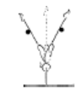 | - maintain body tension and alignment  - head neutral  - move from arch to dish
 | 3. F4-3.1 Awareness – coach lifts gymnast through ideal model (or over cylinder) | 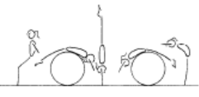 | - maintain body tension and alignment  - head neutral  - hands slightly turned in on contact  - emphasise initial starting and finishing position
 | 4. F4-3.2 Repeat F4-3.1 from a rebound surface | 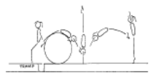 | - maintain body tension and alignment  - head neutral  - hands slightly turned in on contact  - emphasis initial starting and finishing position
 | 5. Spotted flic uphill – land on belly on supersoft mat

MAG LEVEL 3 HORIZONTAL BAR (1)
Hanging & Grip Strength | 1. ® © Lift to L Hang | 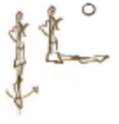
  - Lift legs to momentary L hang.
Front Support /Casts | 1. ®© Cast to free support | 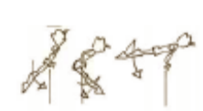
  a) Lack of rhythm or control.
  b) Poor posture in free support
  c) Presentation errors
 | 2. ®* Cast to free support above horizontal | 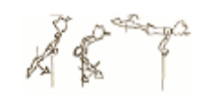
  a) Lack of rhythm or control.
  b) Poor posture in free support
  c) Bent arms in cas
Fwd Roll Dismount | 1. Fwd roll to L hang – hold for 3 secs
Pullover | 1. ®© Hip Pullover to support with assistance | 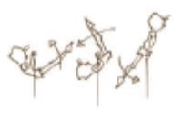
  - Back body pull over with coach’s assistance to front support.
Back Hip circle | 1. B3-1.4 from a jump on a mini tramp to clear front support perform a back hip circle | 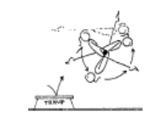 | - bring hips and feet under the bar fast  - fast rotation  - head neutral  - maintain good body tension and alignment  - fast wrist action on completion of circle
 | 2. ® © Back hip circle | 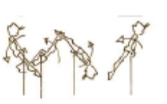
  - a) Lack of rhythm or control.
  - b) Bent arms, legs or body in circle
Long Swings & Long Swing Pullover | 1. ®© Tension swings x 2 | 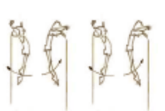
  - Tension swing backwards and forwards two times.
 | 2. B3-4.3 Swing between the bars with a mat over the low bar, gymnast should be able to swing above the low bar to prepare for a good tap between the bars and show a “kicking action” | 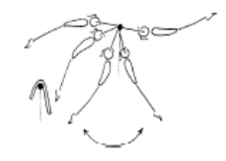 | - ensure a good understanding of the key shapes  - evident power generated from strong tap forward and backward  - maintain good body tension and alignment  - drive feet back under the low bar early to set the early tap
 | 3. B4-5.1 Chin up pullovers x 7
 | 4. Tuck swing pullover on low bar
 | 5 ®© Underswing, 2 x basic swings, back swing dismount | 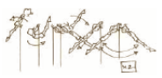 | 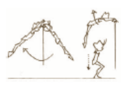
  - Underswing to 2 x basic Swings (at least 60 degrees from lower vertical)
  - On 3rd basic swing, dismount to stand
 | 6. 3 x Tap swings on High bar (from kick start) (*) | 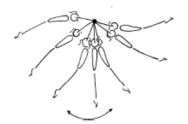 | - smooth rhythm  - swing should gain amplitude  - strong forward tap  - strong backward tap

MAG LEVEL 3 HORIZONTAL BAR (2)
Kips | 1. B4-4.2 Front support flexion/extension activity with coach | 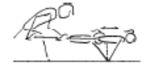 | - strong shoulder action  - chest in  - maintain body tension and alignment  - head neutral
 | 2. B3-6.1 with two feet in a sling, sling kip to front support x 5-10 | 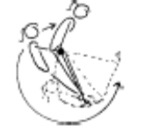 | - feet together with only one foot in the rope  - straight arms  - chest in, hips under, head neutral  - perform 5 - 10 in a series
 | 3. B4-3.3 Coach holds gymnasts feet in straddle position, and assists gymnast to complete kip from a ‘to and fro’ swing to establish rhythm | 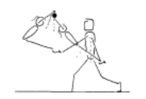 | - learn to “feel the rhythm” of the skill  - keep arms locked  - efficient kip action (hip extension)  - head neutral
 | 4. B4-3.2 short kip from lying on a raised surface – coach spots | 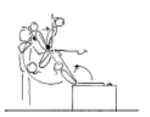 | - straight arms throughout  - keep shoulders open when snapping feet to the bar  - close shoulders strongly and initiate kip action (hip extension)  - efficient hip extension (opening)  - don't open hips all the way - must finish in closed pike position  - head neutral
 | 5. Straddle leg lifts – hanging on a high bar. Show star, rotate hips under through straddle position and up to touch bar x 7
 | 6. B4-3.4 – Drop kip (may be assisted) – used to develop strength in kip action and to improve the ‘rhythm’ of the skill | 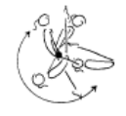 | - commence in a strong front support shape  - maintain shape during swing down  - keep arms locked  - bring the feet to the bar as the shoulders swing around the bar  - relaxed shoulders  - efficient kip action (hip extension)  - head neutral  - strong shoulder flexion then occurs  - move the wrists on top of the bar
 | 7. B3-5.4 Glide 2 feet into basket hang, return to stand | 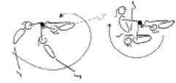
Cast to Handstand | 1. Cast to horizontal, push away to stand on box – repeat x 10

MAG LEVEL 3 VAULT (1)
Bounce /Spring | 1. Ankle raises x 20 with both feet then 15 on each leg
 | 2. V1-5 Springing Circuit – variety of 8 objects | 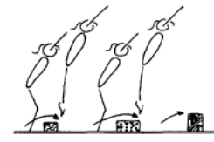 | - maintain good body tension and alignment  - continuous bouncing, no pauses or stops  - easy clearance of the objects
 | 3. Skipping rope x 50
 | 4. V2-4 Run, spring onto a 60cm box & immediately rebound off with a straight jump to land
Running | 1. V3-3.3 hopping (or skipping) – skip along the mat demonstrating the “perfect” running technique during the peak of each skip | 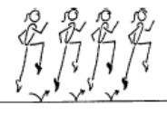 | - head neutral  - extend through ankles and toes  - lift knees to hip height with a fast powerful action  - arms in line with body
Hurdles | 1. Hurdles on Board – correct arms
Catsprings -Handspring Vault | 1. V3-1.1 Handspring flatback from a board to 1 supersoft mat | 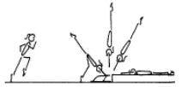 | - underarm action  - tight body in afterflight  - maximum air time  - hands contact board or rebounder early, with  - shoulders fully extended  - fast heel drive (backward body snap)
 | 2. V2-2 Cat springs on floor | 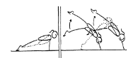 | - arms straight  - good spring  - continuous springing action  - fast explosive action off the floor  - slight stretch through legs and hips
 | 3. Clap pushups with feet on a box and hands on floor
 | 4. Straddle vault over horse (low setting)
 | 5. Squat vault over horse (low setting)
 | 6. “Blocks” onto 60cm box or mat | 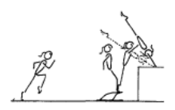 | - low hurdle - to capitalise on speed generated in the run  - contact the board slightly leaning backwards with only minimal flexion of hips and knees  - circle arms down the sides to thrust vigorously forward and upwards so that hands contact the horse as early as possible during the ascent phase
 | 7. “Blocks” onto 90cm box, mat or table
 | 8. ©Short run, handspring from board to land flatback on 60-90cm crashmat (hands on mat) | 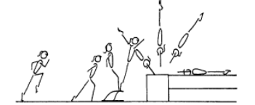 | - fast run  - low hurdle  - underarm action  - repulsion is instantaneous  - dynamic  - fast heel drive (backward body snap)  - hands contact vault early during the upward phase  - maximise air time in after flight  - good body tension throughout - legs straight and together, arms straight, head neutral
Dive Roll / Front Salto | 1. V3-2.1 Hold a dish shape on the floor with feet against a wall
 | 2. V3-2.6 Dive roll from the floor over small shapes onto one supersoft mat
 | 3. V3-2.5 From a short run, using a bench and a board dive roll onto one supersoft mat
 | 4. V3-2 Dive roll onto 60cm
5. V4-1.1 – 1.5 (tramp)
1.1 Back drop to feet
1.2 Hands + knees front salto to back drop to feet
1.3 Hands + knees front salto to feet
1.4 From feet front salto to back drop to feet
1.5 Front salto to land on a soft mat placed on the tramp after take off
 | 6. Spotted front saltos off mini/double mini
 | 7. ®© Tucked front salto from BB onto 1 mat | 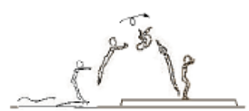
  - Tucked front salto from beat board onto t mat

MAG LEVEL 3 POMMEL (1)
Front Support & Straddle Swings | ®© Straddle swing through front support x 3 | 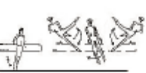
  - Jump through front support to swing to the right and to the left with legs straddled.
Stride Supports & Swings | ®© Stride Swing R leg fwd – no hand release | 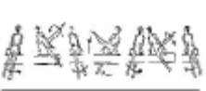
  - Swing both legs to the right; swing right leg in over right handle. Swing to the left in stride support and back to the right. Swing right leg out over the right handle.
 | ®© Stride swing L leg fwd – no hand release | 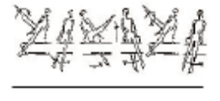
  - Swing both legs to the left side; swing left leg in over left handle. Swing to the right in stride support and back to the left. Swing left leg out over the left handle
 | ®© Stride Swing R Leg Fwd | 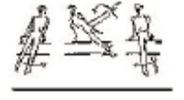
  - Swing both legs to the right; swing right leg in over right handle.
False Scissors | ®* False scissor to the right | 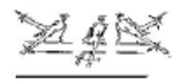
  - Swing left leg in over the left handle. Swing to the right in stride support bringing left leg out over the right pommel (false scissor
Dismount | ®© R Leg over with 90’ Dismount | 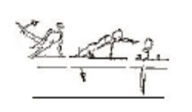
  - Swing to the left in stride support.
  - Swing left leg in over the left handle and dismount with 90º turn to the right.

MAG LEVEL 3 MUSHROOM (1)
Circles | ®© 5 x circles, one at a time | 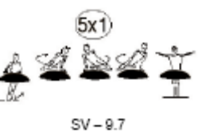
  - From stand, jump to five double leg circles on mushroom.
 | ®* 5 x circles (at least 3 consecutively | 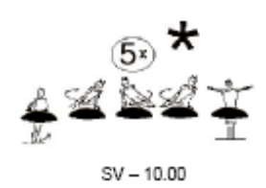
  - From stand, jump to five double leg circles on mushroom (at least 3 circles consecutively)
Dismount | ®© Dismount to stand | 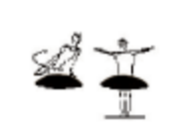
  - Dismount at back of circle to stand.

MAG LEVEL 3 RINGS (1)
Hangs | ®© Lift with bent arms, bent body and straight legs to inverted hang | 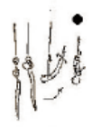
  - Pull with bent arms, bent body and straight legs to stretched inverted hang (2 secs).
 | ®© Dorsal Hang | 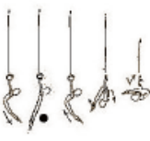
  - Lower legs to a piked position and roll backward to a dorsal hang (2 secs). Pull back to piked position.
Swings | ®* Cast to ½ arm swing | 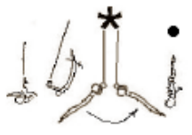
  - Cast with bent arms to swing backward and forward in “chin up” position to stretched inverted hang (2 secs). Lower legs to piked position
 | ®© 2 x swings | 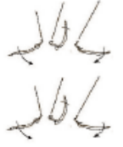
  - Cast to swing backward and forward two times.
 | ®© Swing to inverted hang | 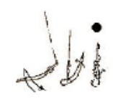
  - Continue to 2nd forward swing to stretched inverted hang. Hold 2 sec
 | ®© Pike cast to 2 x basic swings | 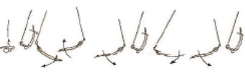
  - Lower legs to piked position and cast to 2 x basic swings.
Dismounts | ®© Bwd wing to dismount | 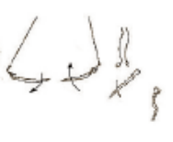
  - On 3rd backward swing, dismount to stand

MAG LEVEL 3 P BARS (1)
Supports | ®© Jump to support (with or without assistance) – lift to L sit | 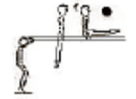
  - From stand in the centre of the bars jump to momentary support with straight body, then lift legs to L-sit (hold 2 secs).
 | ®© Straddle to Sit | 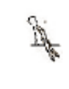
  - Straddle legs to momentary straddle support on the bars, hands behind the hips.
 | ®© Roll back to upper arm and kip to straddle sit | 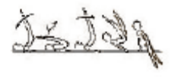
  - From straddle support, roll backwards to a piked upper arm support position and kip to straddle sit (hands behind the legs).
Rolls | ®* Fwd roll to straddle sit | 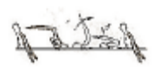
  - Place hands on the bars in front of the legs and roll forward to straddle sit (hands behind the legs).
Swings | ®© Support swing bwd & fwd x 2 | 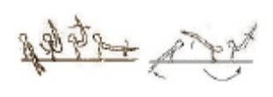
  - Raise legs off the bars toward V support and swing backward at least to horizontal and swing forward.
Dismounts | ®© Swing bwd to dismount over bar | 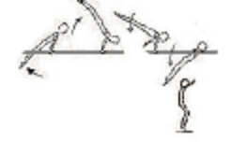
  - Swing backwards to 45º and dismount over one bar to stand.

